Health Indicators: Australia vs OECD Nations
Name of Author:
Institution:
Date:

Introduction
Health care is a critical sector in any nation or society because it underpins the health and wellness of populations needed to stimulate economic growth among other goals. Yet, diverse nations often perform differently regarding the effectiveness and efficiency by which they offer health care services to their populations. Therefore, it is vital to understand the concept of health indicators to ascertain or measure health care performance in line with the needs of the people and communities. In essence, the use of health indicators is ideal to determine the national capacity, ability and efficiency of meeting the health care needs as well as help policy makers make better decisions to improve the sector (Murray and Lopez, 2010: Torun et al., 2017). Having mapped out the significance of the health indices, it is essential to determining how Australia fairs on in comparison with the other nations in the Organisation for Economic Co-operation and Development (OECD). This paper will offer an in-depth analysis and critique on specific health indicators used in Australia, versus those used in the other OECD nations at the global arena. Finally, a determination would be made to ascertain if Australia’s indicators of health care are appropriate relative to the OCED countries.

Key Health Indicators for Australia
Drawing from the 2020 Australia's Health Performance Framework Report prepared by the Australian Institute of Health and Welfare (AIHW), there are five key health care indicators used in the country; Accessibility, Continuity of Care, Effectiveness, Efficiency and Sustainability and Safety. Figure 1 below shows the summary of these indicators:
Figure 1: Australia's Key Health Indicators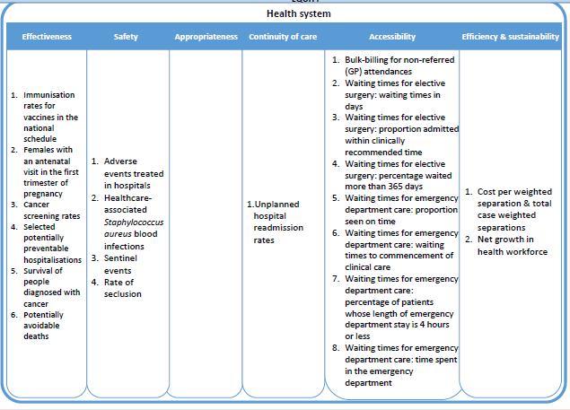
Source: AIHW Report (2020) (https://www.aihw.gov.au/getmedia/fc3986e1-782d-4759-ad2d-24e1b649e4c4/Map-and-descriptions-of-the-AHPF-framework.pdf.aspx)
- Accessibility: In particular, this refers to how the individuals are able to receive the health care services at the right time and place with an emphasis on affordability and their diverse needs. According to the AIHW Report (2020), a specific indicator would be the length of waiting time for elective surgery in terms of days or a patient’s waiting time until they begin clinical care. Longer waiting times signify more inaccessibly which is unfavourable for the patients.

- Continuity of Care: This measure outlines how able the health care sector is in providing uninterrupted service delivery across practitioners, levels and programs over a span of time. A typical indicator could be the unplanned hospital readmission rates within the public hospitals (AIHW Report, 2020). Among some demographics such as among First Nations or non-English background, these rates are higher for diseases such as cardiovascular disease (Shebeshi et al., 2020). The same study emphasizes that women tend to have higher unplanned readmission risk (at 24%) compared to the males.

- Effectiveness: An effective care system is one that attains the desired outcomes not only for patients and communities but practitioners as well. In Australia, effectiveness is assessed through programs like cancer screening and nation-wide immunization schedules (AIHW Report, 2020). Effectiveness is seen in lower hospitalization rates as well as lower mortality rates.

- Efficiency and Sustainability: Unlike effectiveness, efficiency is all about cost. For patients, a health care system is deemed efficient if the cost per hospitalization separation is affordable to most of the population. Matrices such as the public health expenditure versus household income offer insight on costs and affordability of care (Dixit and Sambasivan, 2018). On the other hand, sustainability is about proper use of resources for emerging needs while making a provision for tomorrow’s health care needs (Peacock et al., 2001). Financial prudence may measure how institutions are less wasteful in their resource usage.

- Safety: Finally, safety is about the risk of harm resulting from access to health care such as seclusion rate as an outcome of mental health care or the acquisition of ‘golden staph’ infection due hospital treatment (AIHW Report, 2020). In Australia, rate of adverse effects and seclusion rates are some of factors that show the safety levels of the health care services.
The OECD Health Indicators
At the global level, there are slight differences in which the OECD countries use to measure the performance of the health care systems in comparison to Australia. According to a recent OECD report, there are 20 key indicators and they are summarised in figure 2 below:
Figure 2: OECD Health System Performance Indicators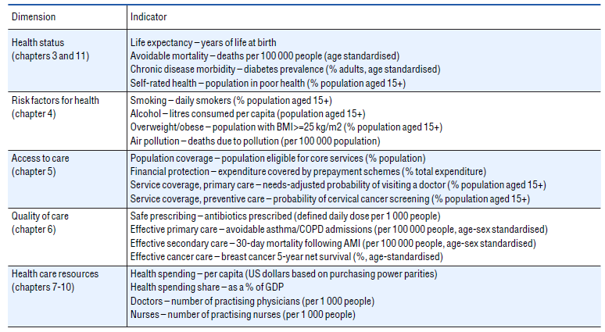
Source: Health at a Glance 2019 Report- OECD.org (http://www.oecd.org/health/health-systems/health-at-a-glance-19991312.htm)

Drawing from the report, these health indicators occur in five main domains. For instance, the Access to care domain concerns those indicators related to how individuals acquire health services (OECD Report, 2019). A specific component such as population coverage looks at the faction of the population under healthcare insurance and thus have the ease of access to health care services as opposed to those relying on out-of-the-pocket payment system. There is also the service coverage that seeks to identify how programs such as the cancer screening are penetrative to communities and populations. Secondly, there is the Quality of care domain with indices such as effective primary and secondary care, safe prescribing and effective cancer care (OECD Report, 2019). Under the effective primary care index, a nation relies on rates of admissions attributed to avoidable diseases such as COPD and Asthma.
Additionally, the Risk factors for Health domain explores the risk factors that expose the populations to treatment such as through smoking tobacco, living in air polluted zones (deaths per 100,000 population) or obesity problems among others (OECD Report, 2019). Then, the healthcare resources measures at the numbers of people and spending attributed to health care service delivery. For instance, the numbers of physicians and nurses per 1000 people and so on. Health spending per capita also provided insights on the purchasing power of health services. Finally, the health status domain outlines specific indicators to wellness such as rise and fall of mortality and life expectancy rates (per 100, 000 persons). The morbidity of chronic illnesses such as diabetes and HIV/Aids among others (OECD Report, 2019). In overall, the OECD indicators are quite related to the Australian indicators but their scope is more comprehensive in informing whether the health care system is performing optimally or not.

The Evaluation of Australia’s Health Indicators & Appropriateness
Firstly, as compared to the international indicators used in the OECD member states, Australia’s indicators are less in coverage. Ideally, more thorough and comprehensive indicators would give a better picture of health performance since most essential components are addressed. For instance, the OECD indicators are more precise to understand the national health workforce in relation to the population serviced. In Australia, the Efficiency and Sustainability indicator only identifies the net growth of the national health workforce over time. As an example, recruiting two thousand physicians would appear to be a great milestone, but only until the population growth within the same time is considered. In other OECD countries, this specific aspect is treated as number of practitioners per 1000 persons. This is a better indicator because it reviews workforce growth relative to the population growth and thus offer better insight to policy makers. In addition, while OECD domain of indicator, Health Status, focuses on morbidity, mortality and changes in life expectancy and these are not expressly captured in Australian analysis of health care performance. This marks a gap in analysing the Australian health care since these factors are not actively sought and analysed.
Further on, the Australian appraisal system of its health care sector offer very open and clear approach making it quite appropriate. For instance, unlike that of the OECD countries, Australia makes a distinction about effectiveness and efficiency in the system. Efficiency is about achieving the set goals and outcomes while efficiency is the prudent use of resources (AIHW Report, 2020). These two are very integral indicators and they largely, the other indicators are anchored on them. For instance, the concept of sustainability in the Australian health care system is well incorporated and milestone have been attained such as rise of climate-friendly hospitals (massive reduction in the carbon footprint) as well as sustainability in resource usage (Braithwaite et al., 2017: Braithwaite et al., 2019). With more technological improvements and new models of care, Australia looks toward being one of the global leaders in sustainable healthcare.
Finally, basing on safety as an indicator, it is essential to conclude that the Australian indicators are quite appropriate but more efforts are needed to comprehensively define indicators that would point to an in-depth understanding of the health sector. With public sector records such as by Australian Commission on Safety and Quality in Health Care indicating a rise in the safety and quality standards, it is vital to note that improvements are certain (Hanley, 2012). Nonetheless, appropriateness concerns how services are people-centric and this is an areas that has room for improvement. Across the demographics, access has been quite a challenge. For instance, Studies such as Corscadden et al. (2019) have found that there are disparities in access of health care in Australia with mental health patients with a condition facing more barriers (10 percentage points higher) compared to other patients. Other studies have acknowledged the health access disparities with indigenous people experiencing difficulties in getting mainstream health services (Davy et al., 2016). In the same way, effectiveness have been challenged with limited penetration of cancer screening programs especially among the rural poor populations (Goodwin et al., 2020).
Conclusion
From the review of scholarly and health data, Australia has a set of well-defined health care indicators that help explain the performance of the system in service of the people and communities. These indicators include; Accessibility, Continuity of Care, Effectiveness, Efficiency and Sustainability and Safety. In comparison to the indicators used by other OECD nations, those of Australia seem to be narrowly defined. In this regard, the Australian health indicators are quite appropriate but do not effectively cover all the essential segments of the health sector. Experts and policy makers may need to emulate some of the indicators from OECD countries such as workforce per population growth and health spending per capita among others. It is essential for a nation to have a comprehensive view of these indicators to truly outline the performance along the any segments. Nevertheless, it does not mean that Australia is low-rated but has made gainful steps in the areas of sustainability, service quality and adaptability making it one of the global leaders in healthcare provision.

References:
Australian Institutee of Health and Welfare (AIHW). (2020). Australia's health performance framework. Retrieved on 25 Jan. 21 from https://www.aihw.gov.au/reports-data/australias-health-performance/australias-health-performance-framework
Braithwaite, J., Testa, L., Lamprell, G., Herkes, J., Ludlow, K., McPherson, E., Campbell, M., & Holt, J. (2017). Built to last? The sustainability of health system improvements, interventions and change strategies: A Study protocol for a systematic review. BMJ open, 7(11), e018568. Doi: 10.1136/bmjopen-2017-018568
Braithwaite J, Zurynski Y, Ludlow K, et al. (2019). Towards sustainable healthcare system performance in the 21st century in high-income countries: a protocol for a systematic review of the grey literature. BMJ Open, 9: e025892. Doi: 10.1136/bmjopen-2018-025892
Corscadden, L., Callander, J., & Topp, S. (2019). Disparities in access to health care in Australia for people with mental health conditions. Aust Health Rev., 43(6):619-627. Doi: 10.1071/AH17259
Davy, C., Harfield, S., McArthur, A. et al. (2016). Access to primary health care services for Indigenous peoples: A framework synthesis. Int J Equity Health, 15, 163-179. Doi: 10.1186/s12939-016-0450-5
Dixit, S. K., & Sambasivan, M. (2018). A review of the Australian healthcare system: A policy perspective. SAGE Open Medicine, 6, 2050312118769211. Doi: 10.1177/2050312118769211
Goodwin, B. C., Rowe, A. K., Crawford-Williams, F., Baade, P., Chambers, S. K., Ralph, N., & Aitken, J. F. (2020). Geographical Disparities in Screening and Cancer-Related Health Behaviour. International Journal of Environmental Research and Public Health, 17(4), 1246. Doi: 10.3390/ijerph17041246
Hanley, E. (2012). Practice-level indicators of safety and quality for primary health care. Australian Commission on Safety and Quality in Health Care. DRAFT Version 3.0. Pp. 1-63
Murray, C., & Lopez, D. (2010). Production and Analysis of Health Indicators: The Role of Academia. PLoS Med 7(11): e1001004. Doi: 10.1371/journal.pmed.1001004
Peackock, S., Chan, C., Mangolini, M., & Johansen, D. (2001). Techniques for measuring efficiency in health services. Working Paper- Productivity Commission. Commonwealth of Australia. Pp. 1-111. Retrieved on 25 Jan 2021 from https://www.pc.gov.au/research/supporting/measuring-health-services/tmeihs.pdf
OECD Report (2019). Health at a Glance 2019: OECD Indicators. OECD Publishing, Paris. OECD.org. Pp. 1-243. Doi: 10.1787/4dd50c09-en
Shebeshi, D. S., Dolja-Gore, X., & Byles, J. (2020). Unplanned Readmission within 28 Days of Hospital Discharge in a Longitudinal Population-Based Cohort of Older Australian Women. International Journal of Environmental Research and Public Health, 17(9), 3136. Doi: 10.3390/ijerph17093136
Torun, P., Heller, R., Harrison, A., & Verma, A. (2017). Can health indicators help policy-makers? Experience from European system of urban health indicators (EURO-URHIS), European Journal of Public Health, 27 (2), 14–18, Doi: 10.1093/eurpub/ckv103

